Typical methods used to prepare remedies in the medieval times:

1. Boiling
2. “pounding”
3. Letting the medicine sit before using
4. Roasting

<http://www.historyextra.com/article/medieval/9-weird-medieval-medicines>

So I was thinking, for some machines to be used, we can have:

* a hamster powered portal and pestle, the portal can be tied on both sides to a wheel that is turned by 2 hamsters tied to either side of it.

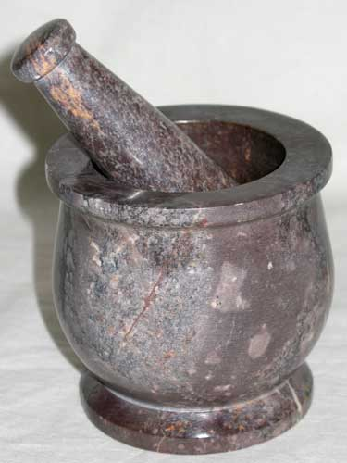

* for boiling we can have a big witches brewing pot that takes up 2 spaces, and a belt goes in it, this way it’s explained how the potions can come out without human intervention. Or you can have a hole to the side of the pot and when the brew is ready it just pours out of it in a bottle.

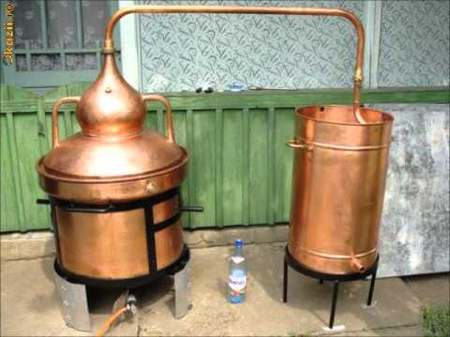 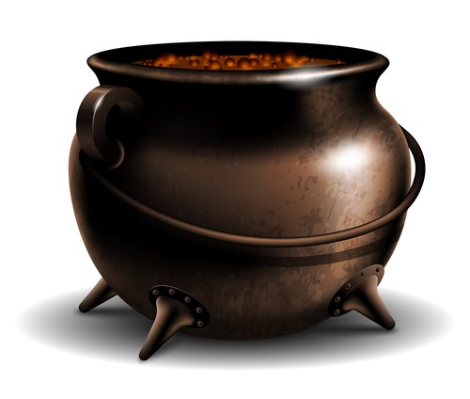

* I’m unsure of how to suggest the letting the medicine sit method can work, unless you have a longer belt which let’s the medicine do it’s thing until it reached another process. Or, close to the output you can have a table where you put the potions and let them sit for 5 minutes before putting them back on the belt to get to the output. Going back to the hamsters, you can have the potion sit by setting a timer on the hamsters. The food is taken from in front of them for 5 minutes, so they stop running. Then after 5 minutes they go back to chasing their food. This way you don’t have to find 101 ways to move about it. But the belts with the ability to take the food away should be more expensive than the normal ones, similar to another machine.

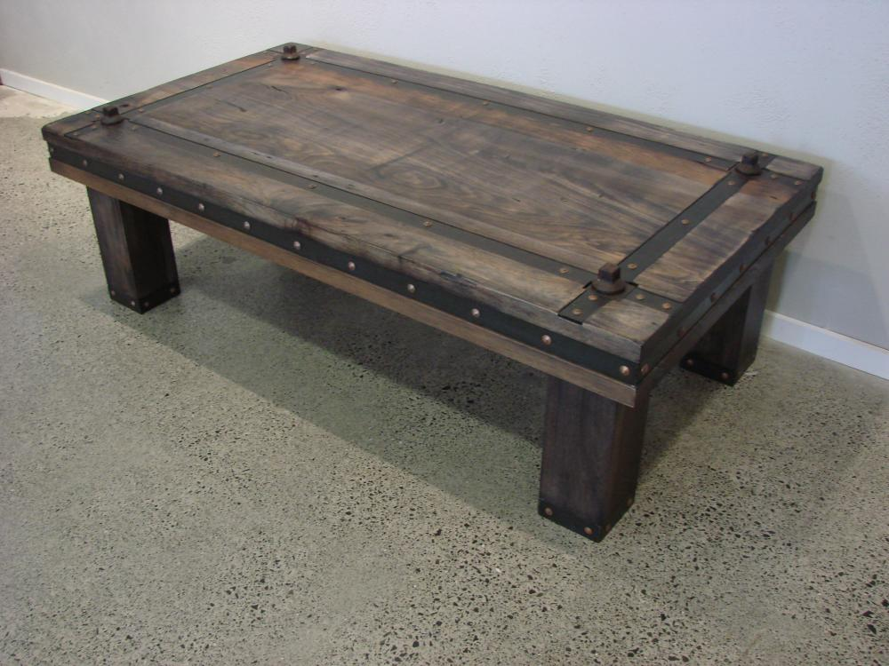

* For the roasting process, I have a concept of it in the one with the hamsters. It can be a wood oven with a belt going through it. They’re usually used for pizzas and bread, but nobody says you can’t give them other uses.

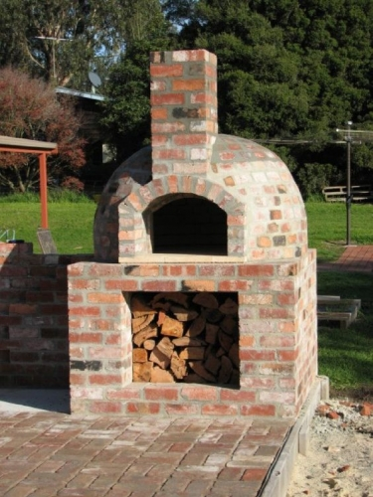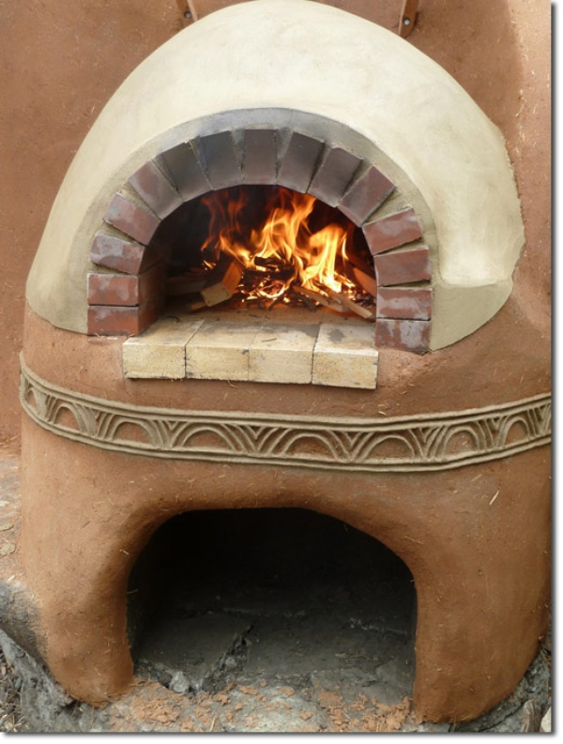

A question I had about the whole line is, how will the potions change from solid ingredients to a liquid solution in a bottle? Should the boiling process be mandatory, so the content can be turned in a liquid solution and then be poured in a bottle? We can’t simply have liquids going down the line in nothing.